**Q. Why we use GAN for super resolution of images?**

**A.** Generative Adversarial Networks (GANs) are used for super-resolution of images because they excel at generating high-quality, realistic images, which makes them well-suited for enhancing the resolution of low-resolution images.

**High-Quality Image Generation**: GANs consist of two networks, a generator and a discriminator. The generator creates high-resolution images from low-resolution inputs, while the discriminator evaluates whether these images are realistic or not. This adversarial process helps the generator produce images that look more natural and detailed.

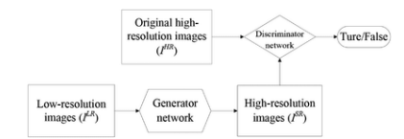

**Perceptual Loss**: In traditional methods, super-resolution focuses on minimizing pixel-wise differences (e.g., mean squared error) between the high-resolution and low-resolution images, which often leads to blurry results. GANs, however, can use a perceptual loss function that focuses on high-level features (e.g., edges, textures) extracted from a pre-trained network, leading to sharper and more visually pleasing images.

Perpetual loss function (LSR), which is used by the SRGAN, is the weighted sum of two types of loss: content loss and adversarial loss. For the generator architecture's performance, this loss is crucial.

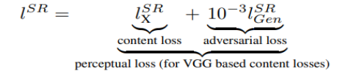

**Learning Fine Details**: GANs are particularly good at learning and recreating fine textures and details in images, which are crucial for high-quality super-resolution. This makes the output images look more realistic compared to outputs from other methods.

**Adaptive Upscaling**: GANs can learn complex mappings from low-resolution to high-resolution images, adapting to different image types and content. This adaptability allows GANs to produce better results across a wide range of images, including faces, landscapes, and text.